Read Table Structure - Code Source

1-Read Table Structure - Ai Question - id 8
# Source: Person Source: Provided by: [Data Path: Persons Table -> ID Column: 1, Name_En Column: Motasem Essam] Written by: [Data Path: Persons Table -> ID Column: 1, Name_En Column: Motasem Essam] on [11/24/2025]
- Create python program to get table structure from access file which select table and
* make it window have button is select file
* when select file if need password give me way to write it if not so we did need it
* when select file i have sub window have all tables i can selet table i want
* when select table get all columns in this format:
Field Name -> Data Type -> Description
* i have two button first is to copy column, second to save file column in file txt or doc

2-Read Table Structure - Ai Answer - id 8
# Source: AI Source: Provided by: [Data Path: Persons Table -> ID Column: 1, Name_En Column: Motasem Essam] -> From: [ChatGPT] on [11/24/2025]
Below is a complete Python program (Tkinter GUI) that:
✔ Lets you select an Access (.mdb / .accdb) file
✔ If the file requires a password, it asks you to enter it
✔ Shows a list of tables inside the database
✔ After choosing a table, it displays the column structure in this format:
Field Name -> Data Type -> Description
✔ Lets you Copy to Clipboard
✔ Lets you Save output to TXT or DOC
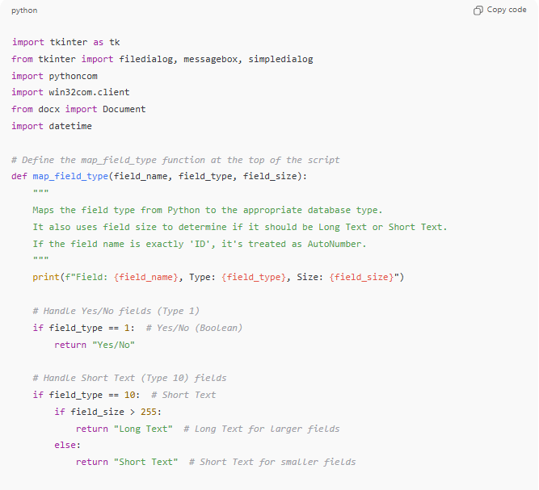
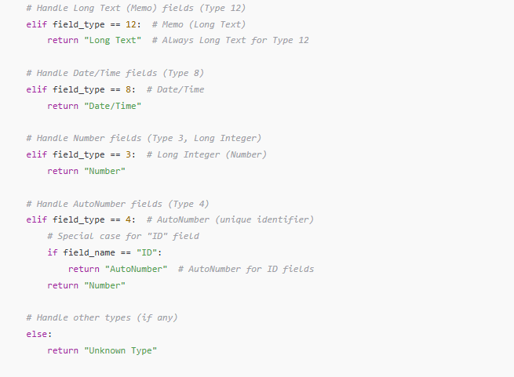
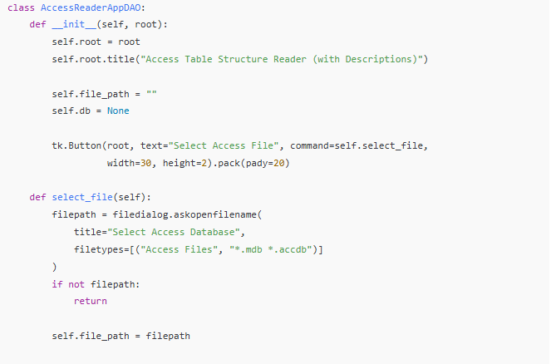
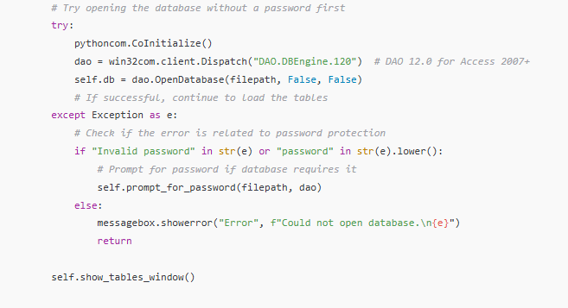
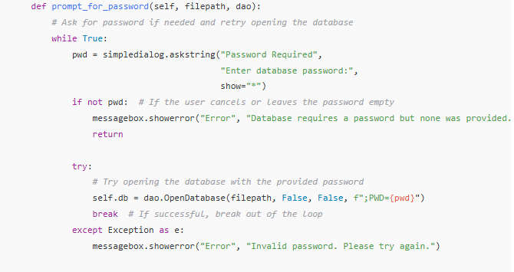
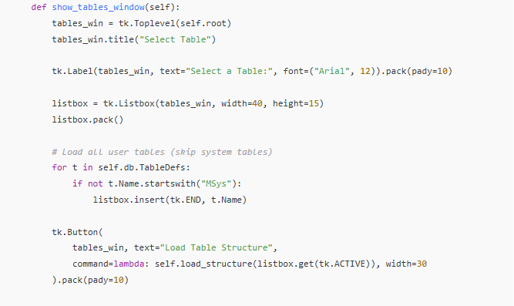
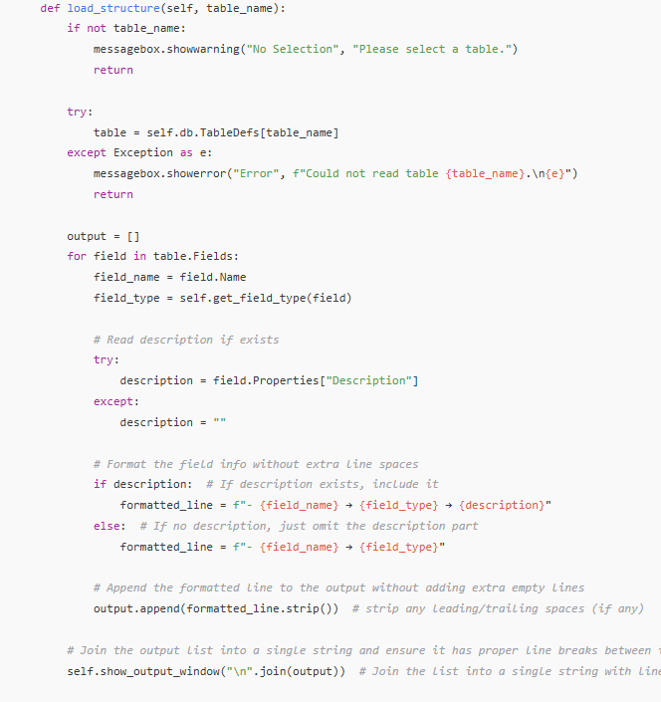
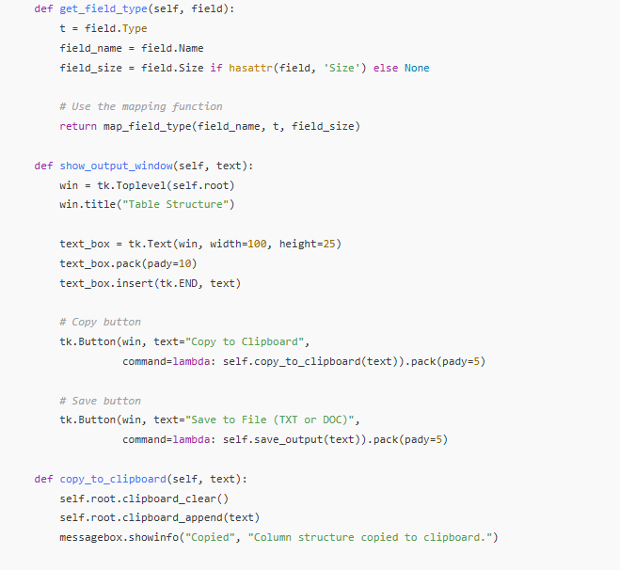
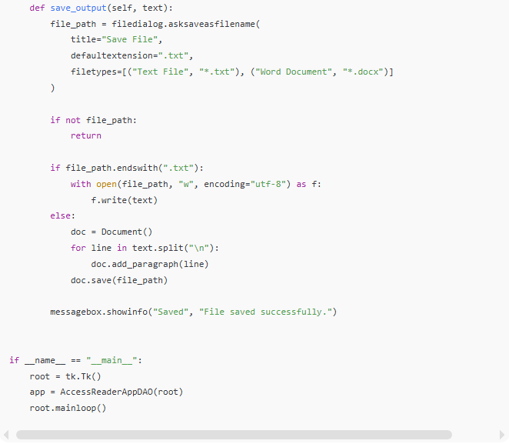
import tkinter as tk
from tkinter import filedialog, messagebox, simpledialog
import pythoncom
import win32com.client
from docx import Document
import datetime

# Define the map_field_type function at the top of the script
def map_field_type(field_name, field_type, field_size):
"""
Maps the field type from Python to the appropriate database type.
It also uses field size to determine if it should be Long Text or Short Text.
If the field name is exactly 'ID', it's treated as AutoNumber.
"""
print(f"Field: {field_name}, Type: {field_type}, Size: {field_size}")

# Handle Yes/No fields (Type 1)
if field_type == 1: # Yes/No (Boolean)
return "Yes/No"

# Handle Short Text (Type 10) fields
if field_type == 10: # Short Text
if field_size > 255:
return "Long Text" # Long Text for larger fields
else:
return "Short Text" # Short Text for smaller fields

# Handle Long Text (Memo) fields (Type 12)
elif field_type == 12: # Memo (Long Text)
return "Long Text" # Always Long Text for Type 12

# Handle Date/Time fields (Type 8)
elif field_type == 8: # Date/Time
return "Date/Time"

# Handle Number fields (Type 3, Long Integer)
elif field_type == 3: # Long Integer (Number)
return "Number"

# Handle AutoNumber fields (Type 4)
elif field_type == 4: # AutoNumber (unique identifier)
# Special case for "ID" field
if field_name == "ID":
return "AutoNumber" # AutoNumber for ID fields
return "Number"

# Handle other types (if any)
else:
return "Unknown Type"

class AccessReaderAppDAO:
def __init__(self, root):
self.root = root
self.root.title("Access Table Structure Reader (with Descriptions)")

self.file_path = ""
self.db = None

tk.Button(root, text="Select Access File", command=self.select_file,
width=30, height=2).pack(pady=20)

def select_file(self):
filepath = filedialog.askopenfilename(
title="Select Access Database",
filetypes=[("Access Files", "*.mdb *.accdb")]
)
if not filepath:
return

self.file_path = filepath

# Try opening the database without a password first
try:
pythoncom.CoInitialize()
dao = win32com.client.Dispatch("DAO.DBEngine.120") # DAO 12.0 for Access 2007+
self.db = dao.OpenDatabase(filepath, False, False)
# If successful, continue to load the tables
except Exception as e:
# Check if the error is related to password protection
if "Invalid password" in str(e) or "password" in str(e).lower():
# Prompt for password if database requires it
self.prompt_for_password(filepath, dao)
else:
messagebox.showerror("Error", f"Could not open database.\n{e}")
return

self.show_tables_window()

def prompt_for_password(self, filepath, dao):
# Ask for password if needed and retry opening the database
while True:
pwd = simpledialog.askstring("Password Required",
"Enter database password:",
show="*")
if not pwd: # If the user cancels or leaves the password empty
messagebox.showerror("Error", "Database requires a password but none was provided.")
return

try:
# Try opening the database with the provided password
self.db = dao.OpenDatabase(filepath, False, False, f";PWD={pwd}")
break # If successful, break out of the loop
except Exception as e:
messagebox.showerror("Error", "Invalid password. Please try again.")

def show_tables_window(self):
tables_win = tk.Toplevel(self.root)
tables_win.title("Select Table")

tk.Label(tables_win, text="Select a Table:", font=("Arial", 12)).pack(pady=10)

listbox = tk.Listbox(tables_win, width=40, height=15)
listbox.pack()

# Load all user tables (skip system tables)
for t in self.db.TableDefs:
if not t.Name.startswith("MSys"):
listbox.insert(tk.END, t.Name)

tk.Button(
tables_win, text="Load Table Structure",
command=lambda: self.load_structure(listbox.get(tk.ACTIVE)), width=30
).pack(pady=10)

def load_structure(self, table_name):
if not table_name:
messagebox.showwarning("No Selection", "Please select a table.")
return

try:
table = self.db.TableDefs[table_name]
except Exception as e:
messagebox.showerror("Error", f"Could not read table {table_name}.\n{e}")
return

output = []
for field in table.Fields:
field_name = field.Name
field_type = self.get_field_type(field)

# Read description if exists
try:
description = field.Properties["Description"]
except:
description = ""

# Format the field info without extra line spaces
if description: # If description exists, include it
formatted_line = f"- {field_name} → {field_type} → {description}"
else: # If no description, just omit the description part
formatted_line = f"- {field_name} → {field_type}"

# Append the formatted line to the output without adding extra empty lines
output.append(formatted_line.strip()) # strip any leading/trailing spaces (if any)

# Join the output list into a single string and ensure it has proper line breaks between items
self.show_output_window("\n".join(output)) # Join the list into a single string with line breaks

def get_field_type(self, field):
t = field.Type
field_name = field.Name
field_size = field.Size if hasattr(field, 'Size') else None

# Use the mapping function
return map_field_type(field_name, t, field_size)

def show_output_window(self, text):
win = tk.Toplevel(self.root)
win.title("Table Structure")

text_box = tk.Text(win, width=100, height=25)
text_box.pack(pady=10)
text_box.insert(tk.END, text)

# Copy button
tk.Button(win, text="Copy to Clipboard",
command=lambda: self.copy_to_clipboard(text)).pack(pady=5)

# Save button
tk.Button(win, text="Save to File (TXT or DOC)",
command=lambda: self.save_output(text)).pack(pady=5)

def copy_to_clipboard(self, text):
self.root.clipboard_clear()
self.root.clipboard_append(text)
messagebox.showinfo("Copied", "Column structure copied to clipboard.")

def save_output(self, text):
file_path = filedialog.asksaveasfilename(
title="Save File",
defaultextension=".txt",
filetypes=[("Text File", "*.txt"), ("Word Document", "*.docx")]
)

if not file_path:
return

if file_path.endswith(".txt"):
with open(file_path, "w", encoding="utf-8") as f:
f.write(text)
else:
doc = Document()
for line in text.split("\n"):
doc.add_paragraph(line)
doc.save(file_path)

messagebox.showinfo("Saved", "File saved successfully.")

if __name__ == "__main__":
root = tk.Tk()
app = AccessReaderAppDAO(root)
root.mainloop()

